5V Buck Rail Transient Response Analysis
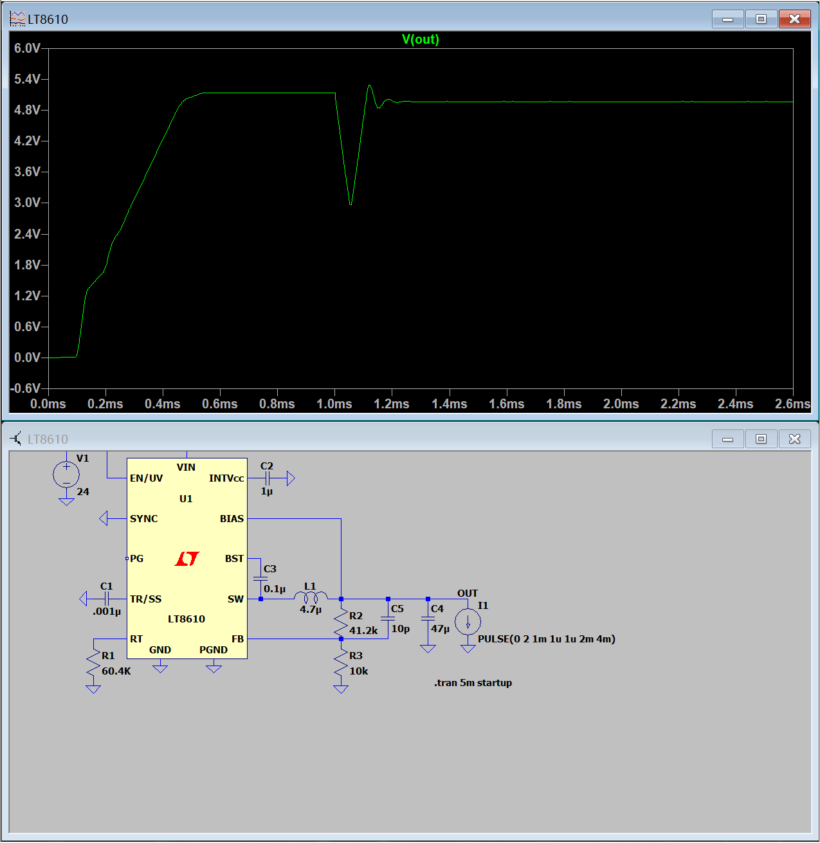

1. Measured Transient Characteristics:
- Transient Undershoot & Overshoot: Upon the 0A to 2A load step at 1.0ms (with a strict 1μs slew rate), the output rail suffers a massive undershoot, plummeting from ~5.1V down to ~2.9V. During the loop's recovery phase, the voltage overshoots to approximately 5.3V.
- Settling Time: The control loop exhibits an underdamped response. The severe ringing takes approximately 200μs to 300μs to dampen and fully settle back to the steady-state nominal voltage.
- Output Ripple: A standard high-frequency steady-state switching ripple is present across the stabilized regions (0.7ms–1.0ms and post-1.3ms).
2. Proposed Compensation & Circuit Improvements: The catastrophic voltage droop and subsequent ringing indicate insufficient charge storage and marginal loop stability. To improve the transient performance, I would implement the following changes:
- Increase Output Bulk Capacitance (Cout): The control loop's bandwidth cannot physically catch a 1μs load step; the initial voltage drop is entirely dependent on C4. Increasing C4 from 47μF to 100μF (or adding a low-ESR polymer capacitor in parallel) will directly minimize the initial 2.9V undershoot.
- Optimize Feedforward Compensation (Phase Margin): The ringing points to a lack of phase margin. I would increase the feedforward capacitor (C5, currently 10pF) placed across the top feedback resistor (R2). This will inject a high-frequency zero to boost the phase lead at the crossover frequency, effectively dampening the overshoot and significantly reducing the settling time.

